**Manipulating items directly**

The elements that you see in Windows PowerShell drives, such as the files and folders in the file system drives, and the registry keys in the Windows PowerShell registry drives, are called items in Windows PowerShell. The cmdlets for working with them item have the noun Item in their names.

The output of the Get-Command -Noun Item command shows that there are nine PowerShell item cmdlets.

PowerShellCopy

Get-Command -Noun Item

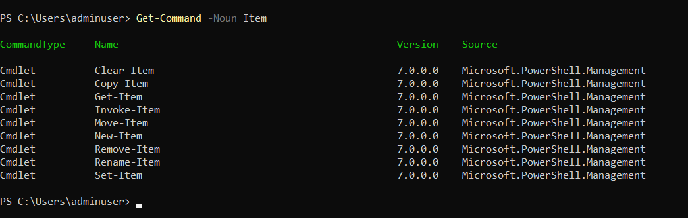

**Creating new Items (New-Item)**

To create a new item in the file system, use the New-Item cmdlet. Include the Path parameter with path to the item, and the ItemType parameter with a value of file or directory

For example, to create a new directory named New.Directory in the C:\Temp directory, type:

PowerShellCopy

New-Item -Path c:\temp\New.Directory -ItemType Directory

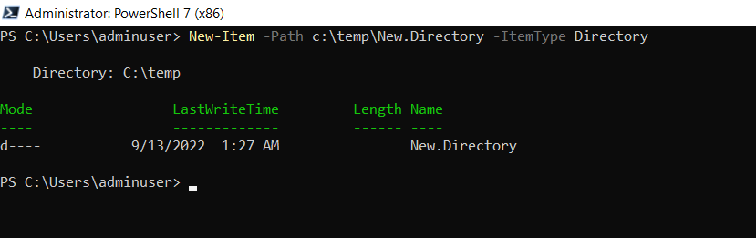

To create a file, change the value of the ItemType parameter to file. For example, to create a file named file1.txt in the New.Directory directory, type:

PowerShellCopy

New-Item -Path C:\temp\New.Directory\file1.txt -ItemType file

You can use the same technique to create a new registry key. In fact, a registry key is easier to create because the only item type in the Windows registry is a key. (Registry entries are item properties.) For example, to create a key named "_Test" in the CurrentVersion subkey, type:

PowerShellCopy

New-Item -Path HKLM:\SOFTWARE\Microsoft\Windows\CurrentVersion\_Test

